Challenge 2: Log Analysis to Ascertain Who Is Compromised and How
KS Gopalakrishnan Potti
Mail : ksgopalakrishnan.06@gmail.com
Contact : 9400505452
Project : Log analysis
1. Executive Summary
This investigation analyzed endpoint web activity, endpoint security events, and USB activity from Org X to identify compromised endpoints and determine the likely method of compromise.
The investigation identified four endpoints with strong evidence of malicious artifacts being present and successfully remediated by the endpoint antivirus system:
- EPGSQVEB
- EPQKOBYG
- EPSES7ZK
- EPVSWBNA
A further eight endpoints showed repeated antivirus remediation of the same malicious recently-used.xbel artifact. These endpoints are classified as likely affected, but are treated separately because the same SHA256 appeared across the cluster and the detections occurred repeatedly during scheduled scans.
One additional endpoint, EPLFOXSS, was classified as suspicious because the antivirus repeatedly attempted to handle a malicious Evolution mail artifact, but there is no evidence that the file was successfully processed or quarantined.
The investigation also examined potential initial-access mechanisms. No reliable evidence was found linking the four strongest cases to either USB media or preceding web activity. Therefore, the available logs establish malicious-file presence and remediation, but do not establish the initial delivery mechanism.
The key forensic conclusion is therefore:
Four endpoints are confirmed as having malicious artifacts that were successfully detected and remediated. Eight additional endpoints are likely affected by a shared malicious artifact. The available telemetry does not establish how the confirmed malicious files originally entered the endpoints.

2. Investigation Objective
The objective of Challenge 2 was to analyze the supplied endpoint telemetry and answer:
- Which endpoints are compromised or affected?
- What malicious artifacts are associated with those endpoints?
- Is there evidence of a common compromise or malware cluster?
- How did the malicious artifacts enter the endpoints?
- Can the initial attack vector be established from the available logs?
The investigation focused on distinguishing actual malware detections from routine quarantine inventory records and then correlating the resulting findings with web and USB activity.

3. Dataset and Methodology
The investigation used three primary datasets.
3.1 Web Activity
data/web_activity.csv
The dataset contains approximately 2.8 million web activity records covering 10–21 September 2026.
The records contain endpoint information, timestamps and contacted destinations.
This dataset was used to investigate:
- Internet destinations contacted by affected endpoints
- Activity preceding malware detections
- Potential download or file-transfer activity
- Web-filter blocks

3.2 Endpoint Security
data/endpoint_security.csv
This dataset contains approximately 23,540 endpoint-security records covering September 2026.
The relevant event types were:
- av_scan
- quarantine
- web_block
The investigation found:
Event type | Records
Quarantine | 20,004
AV scan | 2,622
Web block | 914

3.3 USB Events
data/usb_events.csv
The dataset contains eight USB-related records.
The investigation used these events to determine whether removable storage could have been responsible for malware introduction.
Only one endpoint had a mass-storage device:
- EPD24DBC
- General -UDisk
- Mass Storage
- Vendor/Product: abcd:1234
The other USB activity involved a Logitech optical mouse.
Neither the mass-storage endpoint nor the mouse endpoint corresponds to the confirmed malicious endpoints.
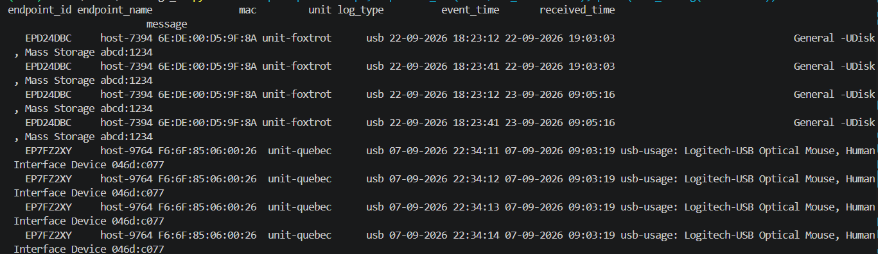
4. Data Validation and Normalization
Before investigating malicious activity, the datasets were normalized and validated.
The following checks were performed:
- Timestamp parsing
- Endpoint consistency
- Endpoint-name consistency
- MAC-address consistency
- Unit consistency
- Dataset coverage
- Timestamp ranges
- Cross-dataset endpoint presence
The analysis identified 248 unique endpoints.
No invalid event_time or received_time values were found.
There were no endpoint-name/MAC/unit inconsistencies.
One endpoint, EPD24DBC, appeared in web activity but not in endpoint-security data.
The timestamp ranges were also established for each dataset.
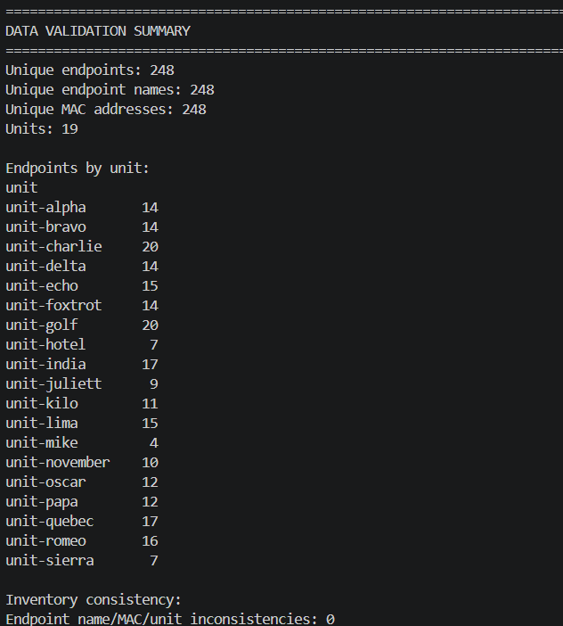
5. Important Finding: Quarantine Records Are Not Infection Events
A major part of the investigation was distinguishing between:
- actual AV remediation, and
- quarantine inventory listings.
The endpoint security system repeatedly lists the contents of the quarantine directory during scans.
Therefore, a row such as:
File: recently-used.xbel
FileType: Malicious
SHA256: ...
does not necessarily mean the file was newly discovered at that timestamp.
The same quarantined file can appear repeatedly.
This distinction was critical because simply counting malicious quarantine records would significantly overestimate the number of compromises.
Instead, genuine AV remediation was identified through messages such as:
Infected files found. Beginning quarantine...
Attempting to handle: <file>
Processing: <file>
Quarantined and deleted: <file>
These events provide substantially stronger evidence that the endpoint actually encountered and remediated the malicious file.
6. Confirmed Compromised Endpoints
Four endpoints have the strongest evidence of malicious-file presence because the endpoint antivirus system successfully processed and quarantined malicious artifacts.
6.1 EPGSQVEB
Malicious artifact
Final_Documents.zip
Two copies were detected:
/home/user6405/Desktop/DOWNLOAD FOLDER/Documents/Final_Documents.zip
/home/user6405/Desktop/DOWNLOAD FOLDER/Projects/Documents/Final_Documents.zip
The SHA256 associated with the malicious artifact was:
404ee57531c33156d62154f49e3700c8c1f09cd0c75692f795748d59b9145088
The AV system recorded:
Infected files found. Beginning quarantine...
Attempting to handle...
Processing...
Quarantined and deleted...
for both copies.
The artifact was subsequently represented in the quarantine inventory as a malicious file.
Assessment
CONFIRMED malicious artifact presence
Evidence:
- AV detection
- Processing
- Successful quarantine/deletion
- Unique malicious hash
- Two local copies
No relevant preceding web activity or USB activity was identified.
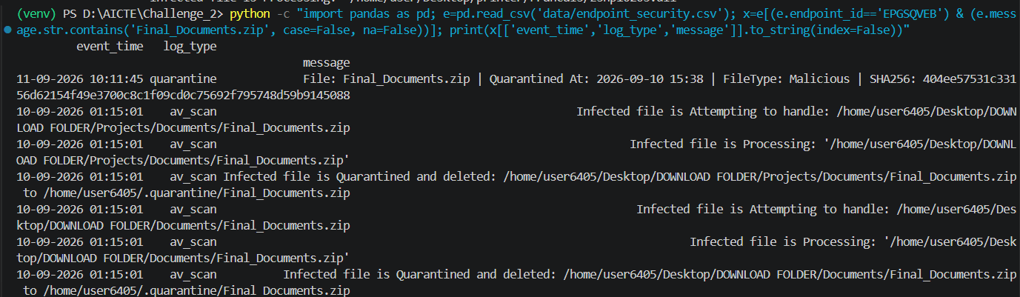
7. EPQKOBYG
Malicious artifact
win-lbp623-621-fw-v1301(1).exe
Location:
/home/usera195/Downloads/
SHA256:
f475a7462dd85932ad7f99354751663d1543adb5e37c7c51ece78e10b6c37189
The AV system successfully:
- Attempted to handle the file
- Processed the file
- Quarantined and deleted the file
The quarantine record subsequently identified it as:
FileType: Malicious
Assessment
CONFIRMED malicious artifact presence
The file's presence in Downloads is consistent with a user-accessible file, but the location alone does not prove that it was downloaded from the Internet.
No relevant preceding web activity or USB activity was identified.
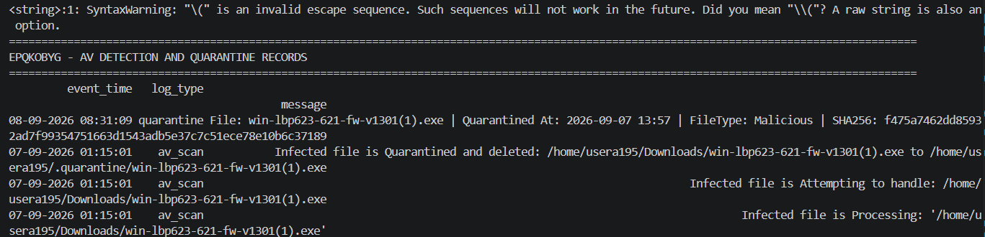
8. EPSES7ZK
Malicious artifact
The endpoint contained five filenames:
hp_LJ1020_Full_Solution-v2012_918_1_57980.exe
hp_LJ1020_Full_Solution-v2012_918_1_57980(1).exe
hp_LJ1020_Full_Solution-v2012_918_1_57980(2).exe
hp_LJ1020_Full_Solution-v2012_918_1_57980(3).exe
hp_LJ1020_Full_Solution-v2012_918_1_57980(4).exe
All five had the same SHA256:
f0c485571570100898f2d15531fbe4531ba303a252cd40a79b64c1976a5a9890
This is important.
The five records do not represent five different malware samples.
They represent one malicious artifact that existed under five filenames/copies.
The AV system successfully processed and deleted all five files.
Assessment
CONFIRMED malicious artifact presence
The identical hash strongly indicates a single artifact duplicated or saved multiple times.
No USB activity was associated with this endpoint.
No relevant web activity was found in the investigated period preceding the AV detection.
A passive hash search also did not identify a reliable public match for the SHA256.
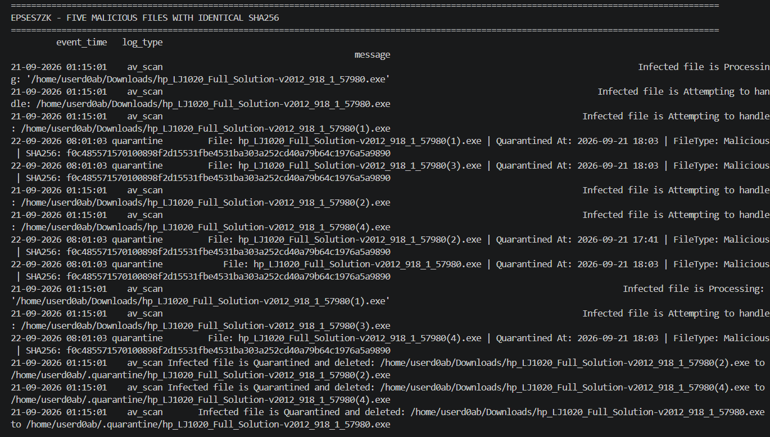
9. EPVSWBNA
Three malicious files were detected together under:
/home/user/Desktop/printer/
The files were:
launcher.exe
English/Strings.dll
Francais/zshp1020s.dll
Their SHA256 values were:
launcher.exe
61a67e53c6c0c80a4e95af35a2997ad2ce59720020fc7438991eda3541df73b6

Strings.dll
ae107170c153cb3eb34c049482722d3937f2c03a6c23cadb9bbdb9034e28b9c0

zshp1020s.dll
c6525c5230387653e16f21f408eab8202157b0eddeb180bd91a13e860fbee4f0
All three files were handled during the same AV scan.
The system recorded:
Attempting to handle
Processing
Quarantined and deleted
for all three.
Assessment
CONFIRMED malicious artifact presence
The three files form a strong local artifact grouping because they are:
- In the same printer-related directory
- Detected during the same scan
- Successfully quarantined
- Associated with three distinct malicious hashes
However, the evidence does not prove that this artifact originated from the same source as the malicious printer-related executable found on EPQKOBYG or the HP installer on EPSES7ZK.
No broader printer-malware campaign can therefore be established from the available evidence.
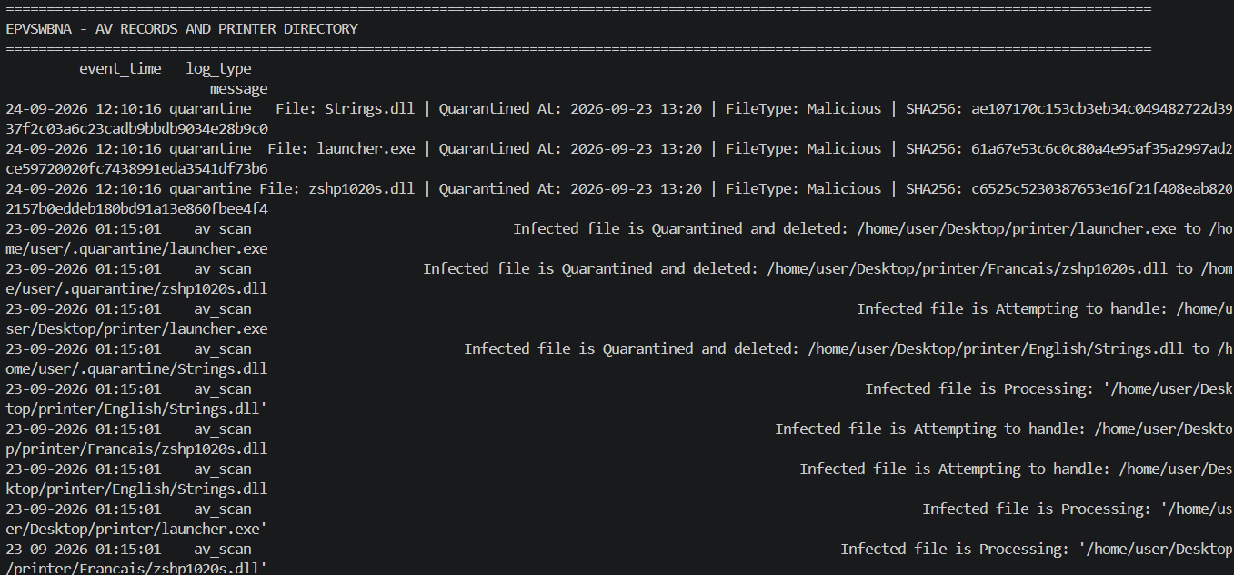
10. Shared recently-used.xbel Cluster
A separate cluster was identified involving eight endpoints:
Endpoint | Unit
EP3GALVS | golf
EPAX5P5D | bravo
EPC2L3UH | india
EPDRB236 | hotel
EPFQSCDV | juliett
EPJYEC7F | romeo
EPMQTKSL | charlie
EPR4BEDS | romeo
All of these endpoints were associated with:
recently-used.xbel
and the same SHA256:
5e10b3490160cca0fc872f2b026d4b40bafc236852f83d30c9031899e50adc9c
The AV system actually processed and quarantined the artifact on these endpoints.
The first observed successful remediation events occurred on:
- EPC2L3UH — 1 September
- EPMQTKSL — 1 September
- EPJYEC7F — 5 September
- EPFQSCDV — 9 September
- EPR4BEDS — 9 September
- EPDRB236 — 12 September
- EP3GALVS — 19 September
- EPAX5P5D — 22 September
The artifact therefore appeared across multiple organizational units over the month.
Interpretation
These eight endpoints are classified as:
LIKELY COMPROMISED / AFFECTED
rather than eight independent confirmed compromises.
The reason is that the exact same artifact/hash appears repeatedly and is repeatedly detected during scheduled AV scans.
The evidence is consistent with a shared malicious artifact or recurring infection/remediation pattern.
However, the available logs do not establish:
- where the artifact originally came from,
- whether it was propagated between these machines,
- whether the machines were independently infected,
- or whether the file represents a consequence of another compromise.
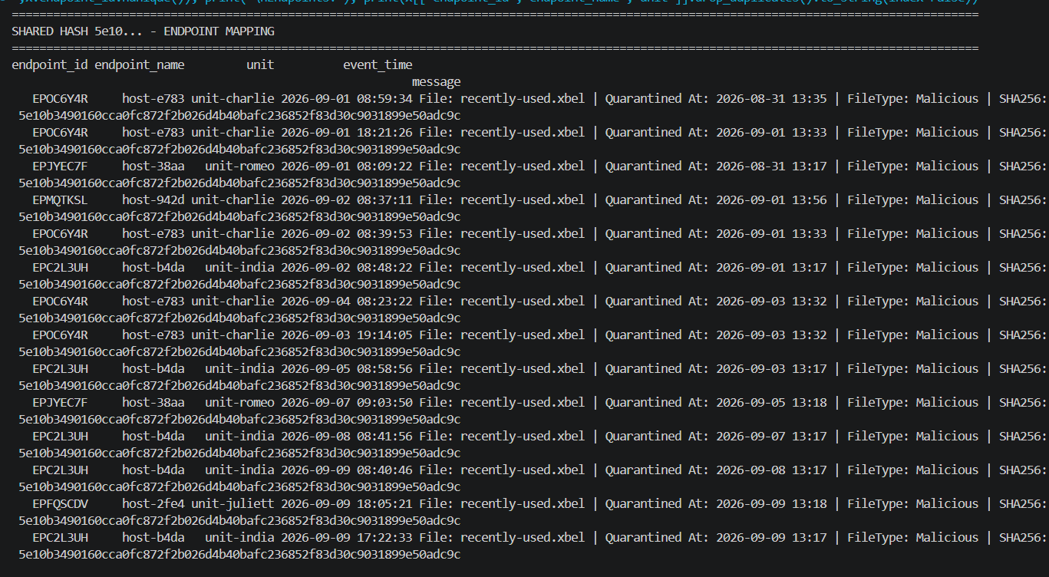
11. Suspicious Endpoint: EPLFOXSS
EPLFOXSS requires separate treatment.
The endpoint repeatedly generated AV events involving:
/home/user6405/.local/share/evolution/mail/local/cur/1773731387.41169_0.EPLFOXSS
There were 14 AV-related events.
However, the AV records show only:
Attempting to handle
There was no corresponding successful:
Processing
Quarantined and deleted
sequence.
The file also did not produce a corresponding malicious quarantine record.
Assessment
SUSPICIOUS, but not confirmed
The artifact's association with an Evolution mail directory makes email-related delivery a possibility, but the available logs do not establish that this was the source of compromise.
Therefore, an email/phishing conclusion would be speculative.
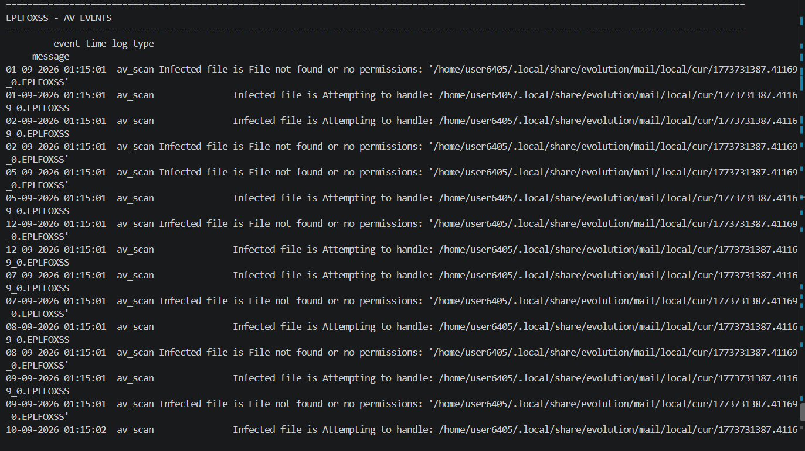
12. Attack Vector Investigation
After identifying the malicious artifacts, the investigation examined potential methods by which they could have entered the endpoints.
Three major possibilities were investigated:
- Web/internet delivery
- USB/removable media
- Email or local file transfer

12.1 Web Activity
Web activity was correlated with the affected endpoints.
Initial broad ±24-hour correlations produced thousands of records, mostly normal background traffic.
This included common infrastructure such as:
google.com
www.google.com
8.8.8.8
dns.google
and synthetic/local service names.
These correlations were therefore considered too broad to establish causality.
A more focused investigation examined activity immediately preceding the relevant AV detections and specifically looked for download/file-transfer indicators.
No useful web precursor was identified for the four strongest confirmed cases.
Finding
No evidence in the available web telemetry establishes that the confirmed malicious artifacts were downloaded immediately before detection.
This does not prove that they were not downloaded earlier.
It only means the available logs do not provide evidence sufficient to establish that mechanism.
13. USB Investigation
USB events were compared against the affected endpoints.
The only mass-storage device was associated with:
EPD24DBC
The confirmed malicious endpoints were:
EPGSQVEB
EPQKOBYG
EPSES7ZK
EPVSWBNA
None of these endpoints had a recorded USB mass-storage event.
Another USB event belonged to EP7FZ2XY and was identified as a Logitech optical mouse rather than removable storage.
Finding
There is no USB evidence supporting removable media as the initial infection vector for the confirmed endpoints.
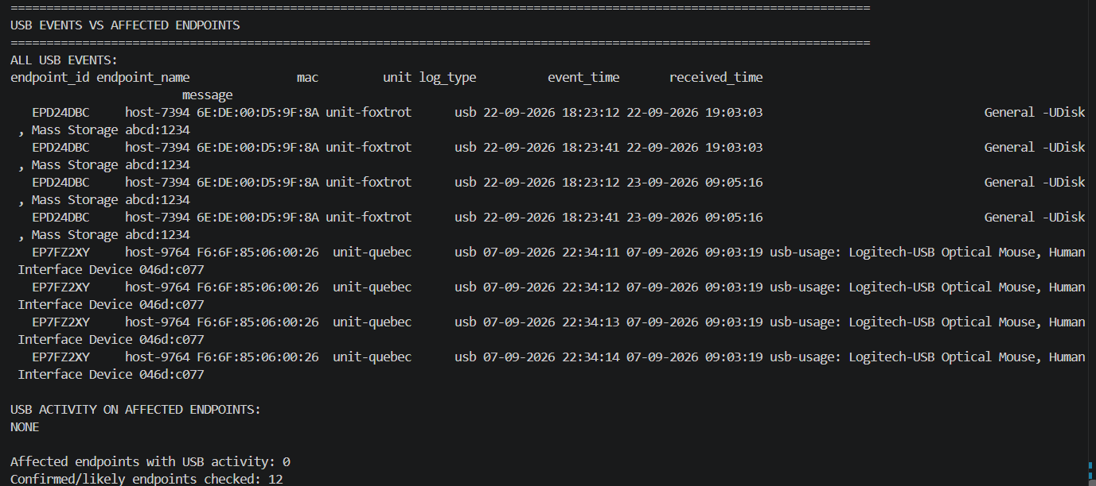
14. Timeline of Major Findings
Date | Endpoint | Event
01 Sep | EPC2L3UH | AV remediation of recently-used.xbel
01 Sep | EPMQTKSL | AV remediation of recently-used.xbel
05 Sep | EPJYEC7F | AV remediation of recently-used.xbel
07 Sep | EPQKOBYG | Malicious printer-related executable remediated
09 Sep | EPFQSCDV | AV remediation of recently-used.xbel
09 Sep | EPR4BEDS | AV remediation of recently-used.xbel
10 Sep | EPGSQVEB | Final_Documents.zip remediated
12 Sep | EPDRB236 | AV remediation of recently-used.xbel
19 Sep | EP3GALVS | AV remediation of recently-used.xbel
21 Sep | EPSES7ZK | Five copies of malicious HP installer remediated
22–23 Sep | EPAX5P5D | Repeated remediation of recently-used.xbel
23 Sep | EPVSWBNA | Three malicious printer-directory files remediated
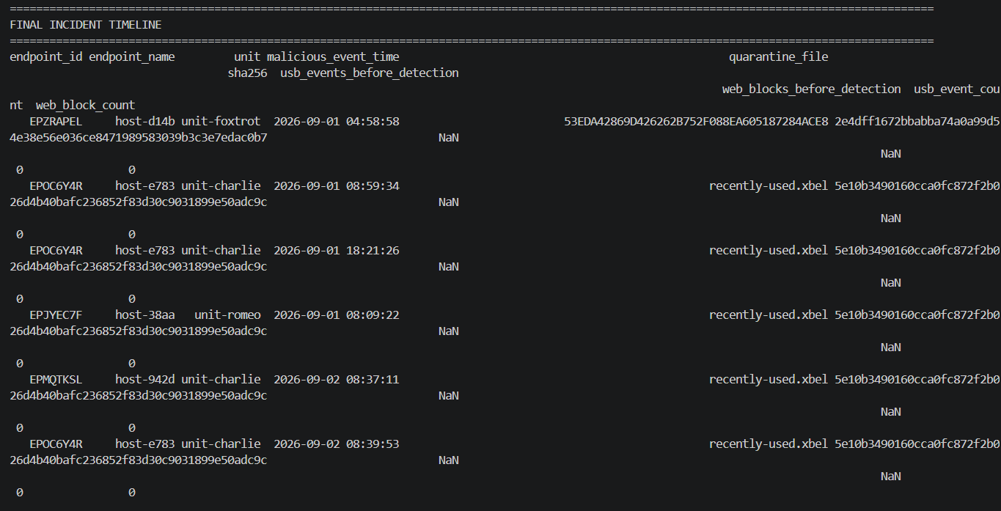
15. Final Classification
Endpoint | Classification | Key Evidence
EPGSQVEB | CONFIRMED | Malicious ZIP successfully quarantined/deleted
EPQKOBYG | CONFIRMED | Malicious executable successfully quarantined/deleted
EPSES7ZK | CONFIRMED | Five copies of one malicious HP installer successfully remediated
EPVSWBNA | CONFIRMED | Three malicious printer-directory files successfully remediated
EP3GALVS | LIKELY AFFECTED | Shared recently-used.xbel malicious artifact
EPAX5P5D | LIKELY AFFECTED | Shared recently-used.xbel malicious artifact
EPC2L3UH | LIKELY AFFECTED | Shared recently-used.xbel malicious artifact
EPDRB236 | LIKELY AFFECTED | Shared recently-used.xbel malicious artifact
EPFQSCDV | LIKELY AFFECTED | Shared recently-used.xbel malicious artifact
EPJYEC7F | LIKELY AFFECTED | Shared recently-used.xbel malicious artifact
EPMQTKSL | LIKELY AFFECTED | Shared recently-used.xbel malicious artifact
EPR4BEDS | LIKELY AFFECTED | Shared recently-used.xbel malicious artifact
EPLFOXSS | SUSPICIOUS | Repeated unsuccessful AV handling of Evolution mail artifact
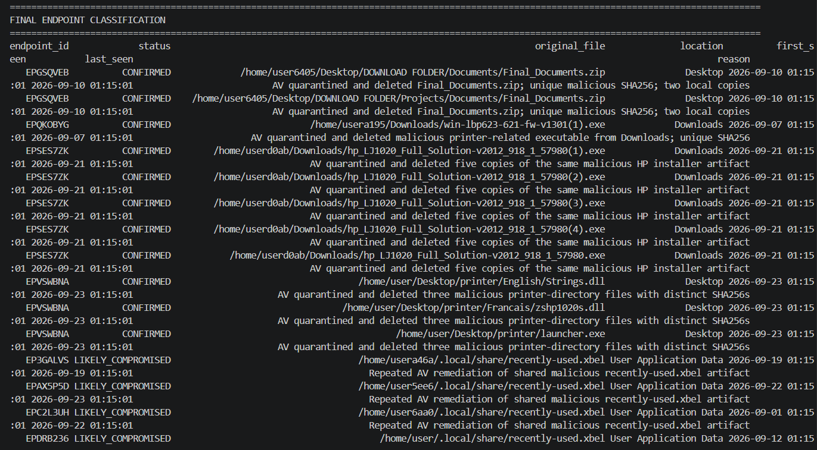
16. Answer to the Challenge: Who Is Compromised and How?
Who?
The strongest evidence identifies four endpoints with confirmed malicious artifact presence:
EPGSQVEB, EPQKOBYG, EPSES7ZK and EPVSWBNA
An additional eight endpoints are likely affected by a shared malicious recently-used.xbel artifact:
EP3GALVS, EPAX5P5D, EPC2L3UH, EPDRB236, EPFQSCDV, EPJYEC7F, EPMQTKSL and EPR4BEDS
EPLFOXSS remains suspicious but unconfirmed.
How?
The available telemetry does not establish the initial attack vector.
Specifically:
- No relevant web precursor was identified for the confirmed cases.
- No USB activity was associated with the confirmed cases.
- Quarantine inventory timestamps cannot be treated as infection timestamps.
- The locations of files such as Downloads and Desktop indicate where the artifacts existed, but do not prove how they arrived there.
- The logs do not contain sufficient evidence to conclusively attribute the files to phishing, web download, USB transfer, email attachment, or another mechanism.
Therefore:
The compromise is evidenced by malicious artifacts detected and successfully remediated by AV, but the initial delivery mechanism remains undetermined from the available telemetry.
This is the most defensible forensic conclusion.

17. Limitations
Several limitations affect the investigation.
17.1 Detection time is not necessarily infection time
The AV scan occurs at approximately 01:15, so a detection at:
2026-09-10 01:15:01
does not mean the malicious file arrived at that exact time.
The file could have existed for hours or days beforehand.
17.2 Quarantine inventory is not a detection timeline
The endpoint security system repeatedly lists quarantine contents.
Consequently, quarantine event timestamps cannot reliably establish when a file first entered the system.
17.3 Absence of web activity is not proof of no download
The lack of a web event before AV detection means that the available web telemetry does not demonstrate a download.
It does not prove that the file was never downloaded.
17.4 No execution evidence
The available datasets establish file presence and AV remediation.
They do not provide sufficient process-execution telemetry to prove whether every malicious file was executed before being detected.
17.5 Limited USB telemetry
The USB dataset contains only eight records, so it can rule out USB activity for the affected endpoints within the supplied telemetry, but cannot provide evidence about USB activity outside that dataset or time period.

18. Recommended Incident Response Actions
For the four confirmed endpoints:
Immediate
- Isolate the endpoints from the network.
- Preserve the relevant endpoint logs.
- Preserve the malicious-file hashes as indicators of compromise.
- Perform a full endpoint forensic investigation.
- Check for process execution associated with the malicious files.
- Check persistence mechanisms.
- Review user activity around the relevant dates.
For the eight recently-used.xbel endpoints
- Treat the shared hash as an IOC.
- Search the entire environment for the SHA256.
- Determine why the same artifact appeared on multiple endpoints.
- Investigate whether the file is being regenerated by another process.
- Check for common software, configuration, or user workflow shared by the affected endpoints.
For the organization
Search endpoint telemetry for:
404ee57531c33156d62154f49e3700c8c1f09cd0c75692f795748d59b9145088
f475a7462dd85932ad7f99354751663d1543adb5e37c7c51ece78e10b6c37189
f0c485571570100898f2d15531fbe4531ba303a252cd40a79b64c1976a5a9890
61a67e53c6c0c80a4e95af35a2997ad2ce59720020fc7438991eda3541df73b6
ae107170c153cb3eb34c049482722d3937f2c03a6c23cadb9bbdb9034e28b9c0
c6525c5230387653e16f21f408eab8202157b0eddeb180bd91a13e860fbee4f0
and the shared:
5e10b3490160cca0fc872f2b026d4b40bafc236852f83d30c9031899e50adc9c
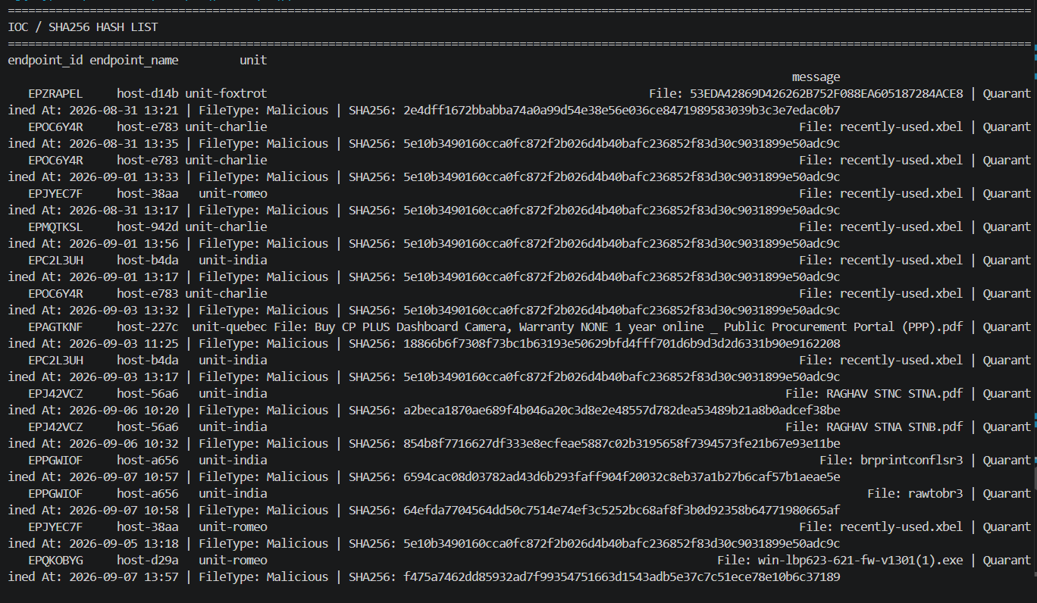

19. Conclusion
The investigation successfully reduced the large volume of endpoint telemetry into a small number of meaningful security findings.
The most important finding is that quarantine inventory alone significantly overstates the number of independent compromises. By correlating quarantine records with genuine AV remediation events, the investigation identified four endpoints with strong endpoint-specific evidence of malicious artifacts.
The confirmed endpoints are:
EPGSQVEB, EPQKOBYG, EPSES7ZK and EPVSWBNA.
Eight additional endpoints show repeated remediation of the same malicious recently-used.xbel artifact and should be treated as likely affected:
EP3GALVS, EPAX5P5D, EPC2L3UH, EPDRB236, EPFQSCDV, EPJYEC7F, EPMQTKSL and EPR4BEDS.
One endpoint, EPLFOXSS, remains suspicious because of repeated unsuccessful AV handling of an Evolution mail artifact.
The available web and USB telemetry does not establish the initial attack vector for the confirmed cases. Consequently, attributing the compromise to phishing, malicious downloads, removable media, email, or another specific delivery mechanism would go beyond the evidence contained in the supplied logs.
Final assessment:
Org X has four endpoints with confirmed malicious artifact presence and eight additional endpoints likely affected by a shared malicious artifact. The endpoint AV successfully detected and remediated the confirmed artifacts, but the available telemetry is insufficient to determine how the initial compromise occurred.

